***REMINDER***
If you are interested in placing a PDA (public display of affection) in the yearbook, they are due Friday, February 23rd!

Examples:
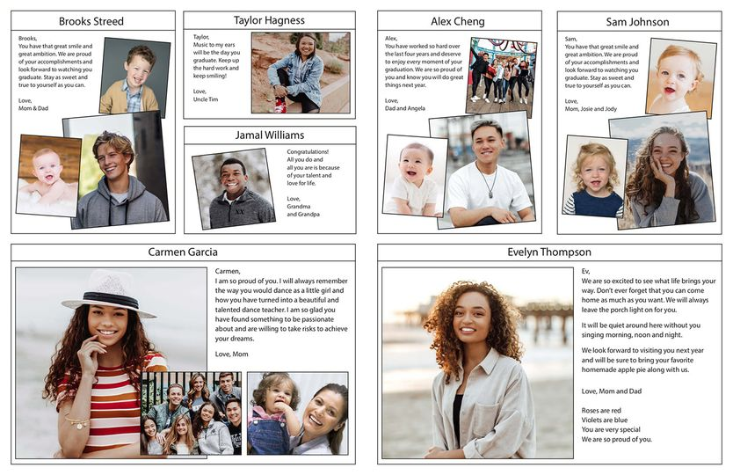

All information and files are also located at www.oliverbeachpta.org

2024 Yearbook PDA Order Form

Yes, I want to post a PDA for _______________________________ in the yearbook!
(print student name / grade)

Ad Size  (please check one) | Price | Maximum number of words in the message | Place a personal message in this space.  If you need additional space to write your message, attach a separate sheet of paper.
- 1/8 page ad | $12.50 | 25
- 1/4 page ad | $25 | 50
- 1/2 page ad | $50 | 75
- Full page ad | $100 | 100

This is a TWO-PART process!

PART ONE: Make your payment at www.OliverBeachPTA.org.

PART TWO: Email a picture and the personalized message to Kelsie Wagner at: oliverbeachyearbook@gmail.com
- OR -
Instead of emailing, complete this form and send this, along with a photo, in
a sealed envelope to school, addressed to OBES PTA / Kelsie Wagner.

Please include your name and phone number in case there are questions.
Please DO NOT send a picture of a picture!

______ Yes, my PDA payment was made online at www.oliverbeachpta.org Amount paid: $________________

Name/Signature: _______________________________ Phone or E-mail: _____________________________________

Note: This is a separate purchase from the yearbook!

